1.Look at the set of ordered pairs below. Determine if the three statements that follow are true or false.
-If it is true, explain why you know that it is true.
-If it is false, explain why you know that it is false and change the statement to a true statement.

{(3,6), (4, 6), (5,7), (6,8), (7,10), (8,10)}

Statement 1:
The relation is not a function because every y-value has more than one corresponding x-value

Statement 2:
The domain of this relation is 3≤x≤8.

Statement 3:
The range of this relation is {6, 7, 8, 10}
Statement 1:
True
A function is a relation for which each value from the set the first components of the ordered pairs is associated with exactly one value from the set of second components of the ordered pair.

Statement 2:
True
The domain of an equation is the set of all x’s that we can plug into the equation and get back a real number for y.

Statement 3:
True
The range of an equation is the set of all y’s that we can ever get out of the equation.

2.The diagram below shows 5 identical bowls stacked one inside the other.

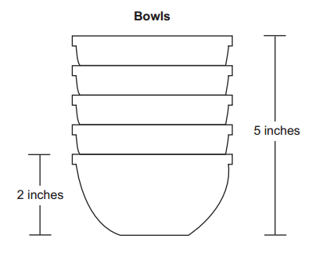

The height of 1 bowl is 2 inches. The height of 5 bowls is 5 inches.

Part A:
Write an equation using x and y to find the height of a stack of bowls based on any number of bowls.
2x-y=5
Part B:
Describe what the x and y variable represent.
X= Number of bowls
Y= The height reduced when bowl is kept in stack
Part C:
Use the equation from Part A to find the number of bowls if the height of the stacked bowls is 12.5 inches.

Part-A
(Bowls, Height) (1, 2) (5,5)
Slope is (5-2)/(5-1) = 3/4 inch
y = (3/4)x + b
(2) = (3/4)(1) + b
(2)-(3/4) = b
B=1.25. Y= 0.75*x + 1.25.
Part B
X is the number of bowls in the stack and Y is the corresponding height of the stack
3.
A cellular phone company charges a $25 monthly fee and an additional $0.10 per minute. If m represents the number of minutes of phone usage, which equation can be used to determine the total monthly cost, c?
25m+0.1m=c
25+0.1m=c
25c+0.1m=c
25m+0.1=c

4. Which graph best represents a line with an x-intercept of (−1, 0) and a y-intercept of (0, 3)?
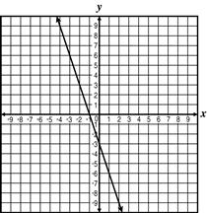
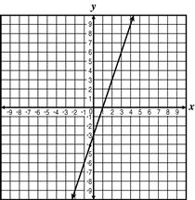Correct
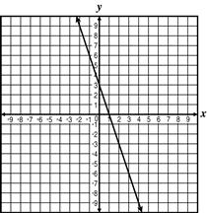
5.Natalie borrowed $1,800 from her mother to purchase a pre-owned car. She agrees to repay this amount by paying her mother $45 per week. This situation can be modeled by the function Which inequality represents the domain for this function?
Correct
6.Which equation represents the line that passes through the points and
Correct
7.Which relation below is NOT a function?
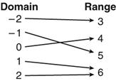
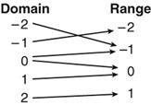
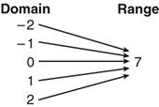
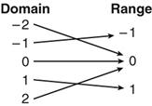Correct
8.The Shaffer family started on a trip in their car with 18 gallons of gasoline. The car uses 2 gallons of gasoline every hour. If t represents the number of hours spent driving and g represents the number of gallons of gasoline left in the car, which equation could be used to calculate the value of g, if
Correct
9.
The values given in the table below are the coordinates of points on a line.
x | 1 | 2 | 4
y | 3 | 8 | 18
What is the slope of this line?
Slope=(18-8)/(4-2)=5
10
4
5
3
10.Trapezoid ABCD is drawn on a coordinate grid below. The coordinates for A, B, C, and D are (0, 0), (10, 0), (8, 6), and (2, 6) respectively.
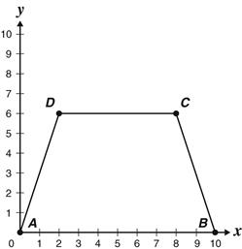
What is the equation for the line containing
Correct
11.The graph of which equation is a horizontal line?
Correct
12.
The head of the Drama Department is trying to determine the price to charge for tickets to the next production. The graph shows the relationship between ticket prices and number of tickets sold for past productions.
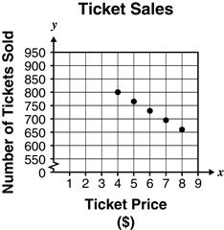
Which equation represents the line of best fit for this data?
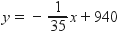
Correct
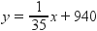
13.
Which of the following equations is graphed below?
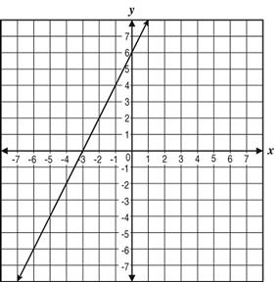
Correct:2x-y=-6
14.
Which relation below is a function?
x | y
0 | –1
1 | –2
0 | –3
2 | –4

x | y
0 | 0
1 | 1
0 | 4
2 | 9

x | y
0 | 1
1 | 2
0 | 3
2 | 4

Correct:

x | y
0 | 0
1 | –2
4 | 5
2 | 2

What is the slope of the line that passes through the points and
Correct
16.
Which of the following sets of ordered pairs is a function?
17.
What is the y-intercept of the graph of the equation
Answer
18.
Mr. Smith withdrew $6,000 from his savings account to purchase a car. He plans on depositing $250 per month into his account in order to make up for the amount he took out. Which graph BEST represents the length of time it will take to replace the money in his account?
Answer
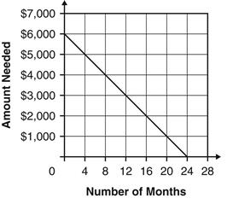
19.
The scatterplot below shows the population, P, of a small town in different periods of time. The time, t, represents hundreds of years, and t = 0 represents the year 2000.
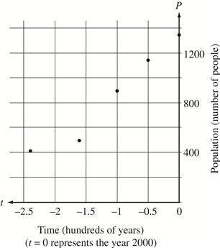
Which of the following equations BEST models the data in the scatterplot?
Answer:
20.
The Happy Ride Amusement Park offers the two admission plans described below. A visitor to the park plans to buy tickets for a number of rides. For what number of rides would the total cost of Plan X be equal to the total cost of Plan Y?
Plan X: $13.00 admission fee plus $2.00 for each ride ticket
Plan Y: $4.00 admission fee plus $3.50 for each ride ticket
2
6
11
Answer:
3
21.
Which graph best represents the line that passes through the points and
Answer:
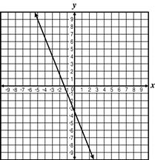
22.
The cost of an ice cream cone is measured by the formula where x is the number of scoops of ice cream and c is the cost. According to the formula, how much should it cost to buy an ice cream cone without the ice cream?
Answer:
$0.25
23.
In the equation the expression would replace which part of the equation?
the coefficient
the variable
the slope
the variable

Assessment #14: Scatter Plots
1.
Home heating costs and outside temperatures for 15 families are shown in the scatterplot below.
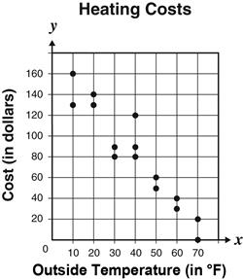
Which statement BEST describes these data?
There is a positive correlation between the outside temperature and the heating cost.
There is a negative correlation between the outside temperature and the heating cost.
There is a constant correlation between the outside temperature and the heating cost.
There is no correlation between the outside temperature and the heating cost.
2.
The table displays life expectancy data for males and females in the United States from 1960 to 1985.
Life Expectancy (years)
in the
United States
Year | Male | Female
1960 | 66.6 | 73.1
1965 | 66.8 | 73.7
1970 | 67.1 | 74.7
1980 | 70.0 | 77.5
1985 | 71.2 | 78.2

Which statement is supported by this data?
Male life expectancy has increased more than female life expectancy.
Both female and male life expectancy has increased.
Male life expectancy has increased at a faster rate than female life expectancy.
Female life expectancy has been the same as male life expectancy.
3.
The scatterplot below shows the relationship between the number of minutes a student studied for a test and the grade the student received for the test in Ms. Miller’s class.
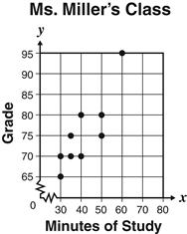
Which conclusion is BEST supported by the data?
A student who studied longer always did better than a student who studied less.
A student who studies 80 minutes will receive a grade of 95 on the test.
A student who studied longer generally did better than a student who studied less.
A student who studies 45 minutes will receive a grade of 75 on the test.
4.
The temperature of a chemical substance was recorded each hour during a 12-hour period, as shown on the scatterplot below. The temperatures on the y-axis range from freezing (0°C) to boiling (100°C).
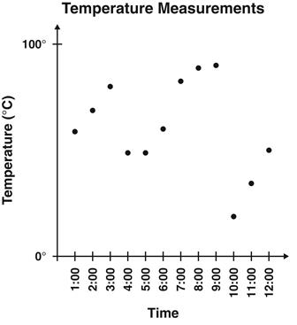
Based on the data in the plot, which temperature range BEST represents the recorded temperatures from 3:00 to 6:00?
0°C to 100°C
50°C to 80°C
60°C to 70°C
20°C to 90°C
5.
Which of the following equations best models the data in the scatterplot below?
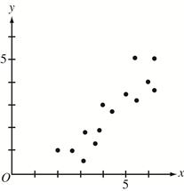
y = –x + 2
y = x – 2
y = x + 2
y = –x – 2
6.
The scatterplot below suggests which of the following types of data relationship?
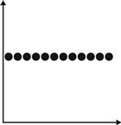
zero correlation
strong negative correlation
strong positive correlation
weak positive correlation
7.
The heights and weights of 10 people are represented on the scatterplot below.
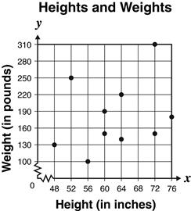
What type of relationship exists between the heights and weights of these 10 people?
positive
constant
none
negative
8.
The graph shows the temperature from 12:00 p.m. to 6:00 p.m.
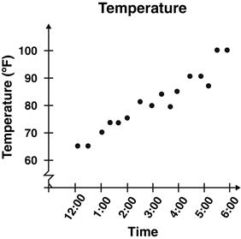
What type of trend is shown in the graph?
No trend is shown in the graph.
positive
constant
negative
9.
Jan practices free throws in basketball practice every week. She recorded the number of free throw points she made and the time she spent practicing on the graph below.
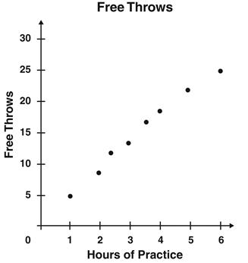
Based on the graph, which statement is true?
The shorter amount of time Jan practices, the more free throw points she makes.
There is no relationship between the number of free throw points Jan makes and the amount of time she spends practicing.
The more time Jan practices, the more free throw points she makes.
The more time Jan practices, the fewer free throw points she makes.
10.
The scatterplot shows pairs of final exam grades (x, y) for a group of students.
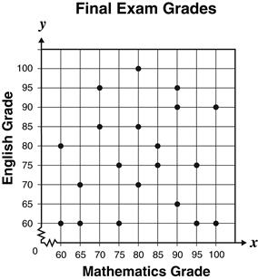
Which phrase is the BEST description of the correlation between the mathematics exam grades and the English exam grades?
neither positive nor negative
normal or standard
strongly positive
strongly negative
11.
Mr. Sanchez recorded the number of visitors to a county park for 20 days and the average temperature for these 20 days. He recorded his data on the scatterplot below.
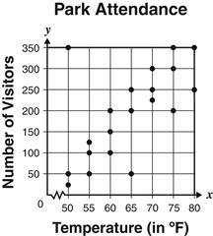
Which statement BEST describes the relationship between the number of visitors and the average temperature for these 20 days?
As the temperature increased, the number of visitors increased.
As the temperature increased, the number of visitors decreased.
As the temperature decreased, the number of visitors remained constant.
As the temperature decreased, the number of visitors increased.
12.
Which equation most closely represents the line of best fit for the scatter plot below?

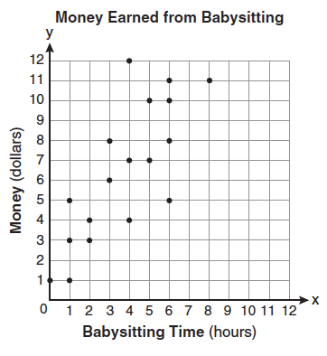

y=x

y=32x+1

y=32x+4

y=23x+1

13.
The graph shows the value of a car at the time of purchase and after each of the next 8 years.
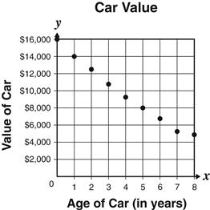
According to the graph, which statement is true?
As the age of the car increased, the value of the car decreased.
The value of the car decreased at the same rate each year.
As the age of the car increased, the value of the car did not change.
The value of the car decreased $2,000 after the first year, so the value after 8 years should be $0.
14.
What type of correlation is shown in this graph?
Strong positive correlation
Strong negative correlation
Weak positive correlation
Weak negative correlation
15.
A person is waiting in line to get into a sporting event. The data in the table represents the relative position, in feet, of the person to the entry gate over time in seconds.
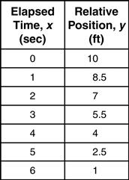
What does the slope of the linear equation that models the data represent?
The person’s speed is decreasing as the person approaches the entry gate.
The person is moving farther away from the entry gate at a rate of 1.5 feet per second.
The person’s speed is increasing as the person approaches the entry gate.
The person is moving closer to the entry gate at a rate of 1.5 feet per second.
16.
The scatterplot below suggests which of the following types of data relationship?
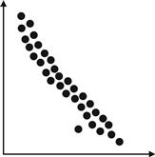
strong negative correlation
weak positive correlation
strong positive correlation
weak negative correlation
17.
The scatterplot below suggests which of the following types of data relationship?
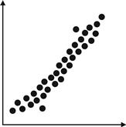
weak negative correlation
strong negative correlation
strong positive correlation
weak positive correlation
18.
The number of hours spent on math homework each week and the final exam grades for twelve students in Mr. Dylan's algebra class are plotted below.
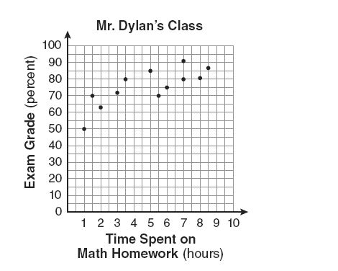
Based on a line of best fit, which exam grade is the best prediction for a student who spends about 4 hours on math homework each week?
82
62
72
92
19.
The scatterplot below suggests which of the following types of data relationship?
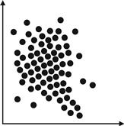
strong positive correlation
strong negative correlation
weak negative correlation
weak positive correlation
20.
Hank counted the number of scratches on cars of different ages. Hank then created the scatter plot below showing the relationship between the age of a car (x) and the number of scratches found on the car (y).

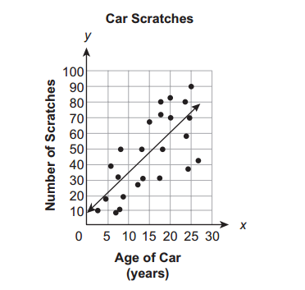
Part A:
In 3-4 sentences, describe why this is the line of best fit for the data shown on the graph. Be sure your explanation includes the following words:

-Positive Correlation or Negative Correlation
-line of best fit
-Strong Correlation or Weak Correlation
-data points
-scatter plot

Part B:
Use the line of best fit to predict the number of scratches in a car when the age of the car is 30 years old. Explain how you arrived at your conclusion.
Since the line visually passes through this grid line and there are no points for x = 30

21.
The manager of a company wants to accurately predict the increase in the number of products sold per year. The table and graph show information the company collected. Using the information, the company fit the given line to the data.
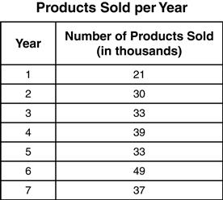

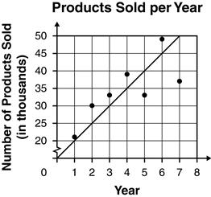

Which statement best describes the use of residuals in determining how the graph of the function fits the data?
Since the sum of the squares of the residual errors is 285, a large number, the graph of the line is close to the line of best fit.
Since the majority of the residual errors are positive, the graph of the line is close to the line of best fit.
Since the sum of the squares of the residual errors is 285, a large number, the graph of the line is not close to the line of best fit.
Since the majority of the residual errors are negative, the graph of the line is not close to the line of best fit.
22.
John recorded the weight of his dog Spot at different ages as shown in the scatter plot below.
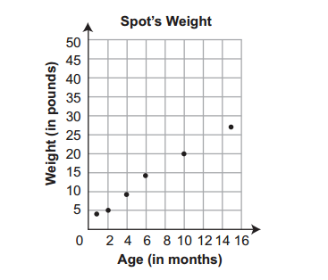
Part A:
Write an equation that would describe the line of best fit.
Slope=(20-5)/(10-2)=15/8
y=15/8x +10
Part B:
Using the line of best fit, make a prediction of Spot's weight after 18 months.
y=(15/8)*18+10=43.75

23.
Keith is hiring a contractor to do some work on his house. He asks eight contractors to provide an estimate of their total time to complete the work and the total amount of money they will charge. The results are shown in the graph below.
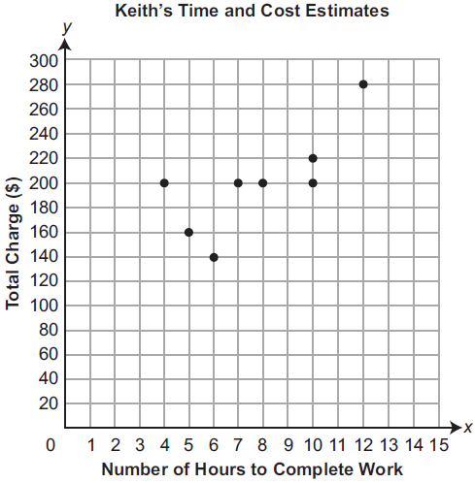
Which equation most closely matches the line of best fit for Keith’s time and cost estimates?
y = 15x + 50
y = 10x + 160
y = 10x + 115
y = 200

4.
Estimate an equation for the line of best fit for the following scatter plot.
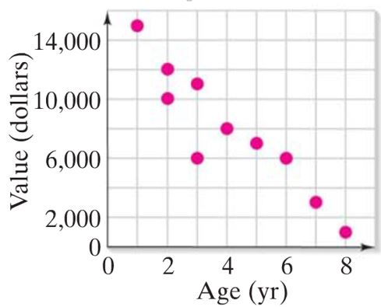
Slope=(8000-6000)/(4-3)=2000
y-8000=2000(x-4)
y=2000x

5.
Megan heated up a cup of coffee over the stove. The scatter plot below shows the temperature (y), in degrees Celsius (^degC), of the coffee based on the number of minutes (x) she heated the coffee.
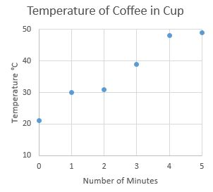
Which equation describes the line of best fit for the temperature of the coffee based on the number of minutes Megan heated it over the stove?
-5.6x + 21
5.6x + 12
-5.6x + 12
5.6x + 21

1.
Given the scatter plot below, the equation for the line of best fit is y=25x+3.

Explain what the y-intercept represents in terms of the number of guests and pizzas. Your explanation should be at least 3-4 sentences and include at least 5 of the following words/phrases.

- "Trend Line" or "Line of best fit"
- ordered pair
- independent variable
- dependent variable
- "y-axis" or "x-axis"
- y-intercept

y-intercept is 3

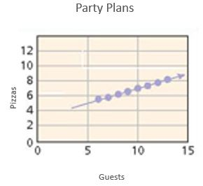

DESCRIPTION 1 of 52 of 53 of 54 of 55 of 5
SUBMITTOGGLE DROPDOWN
New version available! (3.0.178)
New version available! (3.0.178)
GET IT NOW

Assess It #85: Day 147
1.
Given the scatter plot below, the equation for the line of best fit is y=25x+3.

Explain what the y-intercept represents in terms of the number of guests and pizzas. Your explanation should be at least 3-4 sentences and include at least 5 of the following words/phrases.

- "Trend Line" or "Line of best fit" _Positive
- ordered pair
- independent variable - Guests
- dependent variable – Pizzas
- "y-axis" or "x-axis"
- y-intercept
y-intercept is 3

2.
The scatter plot shows data for the size of television screens from the years 2007 - 2016. How might the equation for the line of best fit change if you only considered data from 2010 - 2016?

Your answer should be at least 3- 4 sentences and include at least 6 of the following words/phrases:

- "Trend Line" or "Line of best fit"
- Slope
- "increases" or "decreases"
- independent variable -Year
- dependent variable – Average TV Screen Sizes
- "positive correlation" or "negative correlation"
- y-intercept
- ordered pair
- "y-axis" or "x-axis"

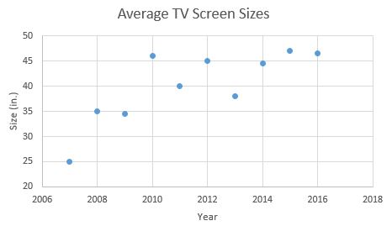

3.
What does the y-intercept in the scatter plot represent?

Your answer should be at least 3- 4 sentences and include at least 4 of the following words/phrases:

- "Trend Line" or "Line of best fit" Positive
- ordered pair-(0,8)(2,10)
- independent variable –Number of Years
- dependent variable – Pay Per Hours
- "y-axis" or "x-axis"
- y-intercept
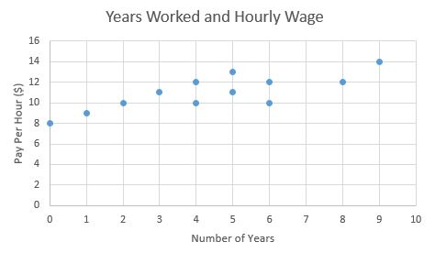

4.
Given the scatter plot below, the equation for the line of best fit is y=25x+3.

Explain what the slope represents in terms of the number of guests and pizzas. Your explanation should be at least 3-4 sentences and include at least 5 of the following words/phrases.

- "Trend Line" or "Line of best fit" -Positive
- Slope
- "increases" or "decreases"
- independent variable -Guests
- dependent variable -Pizzas
- "positive correlation" or "negative correlation"

Slope is 25

5.
What does the slope in the scatter plot represent?

Your answer should be at least 3- 4 sentences and include at least 6 of the following words/phrases:

- "Trend Line" or "Line of best fit"
- Slope
- "increases" or "decreases"
- independent variable
- dependent variable
- "positive correlation" or "negative correlation"
- y-intercept

Slope=(10-8)/2-0)=2/2=1

New version available! (3.0.178)
GET IT NOW

Assess It #84: Days 145 - 146
1.
Identify the type of correlation that is present in the scatter plot.
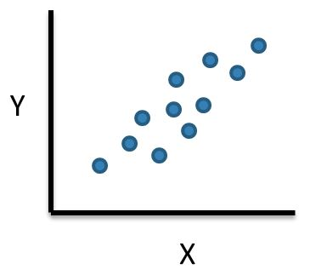
positive correlation
negative correlation
no correlation
2.
Which line of best fit is the best choice for the data given below?
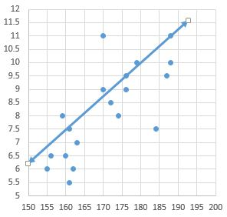
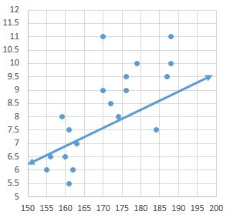
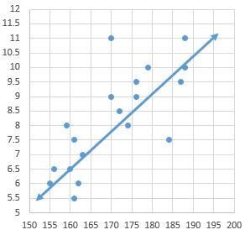
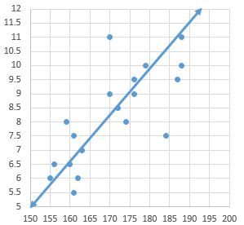-Correct
3.
Which line of best fit is the best choice for the data given below?
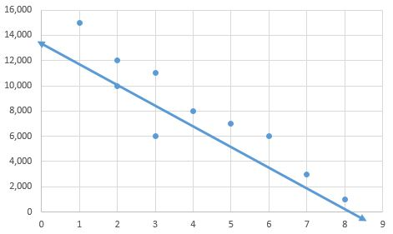
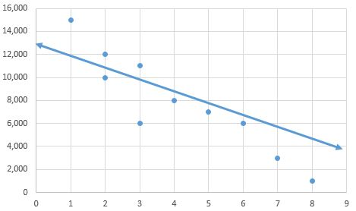
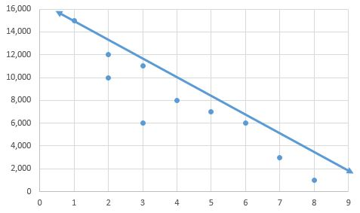
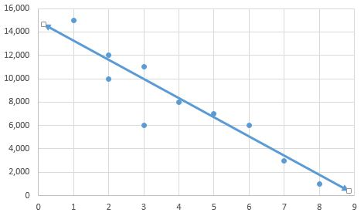
Correct
4.
Identify the type of correlation that is present in the scatter plot.
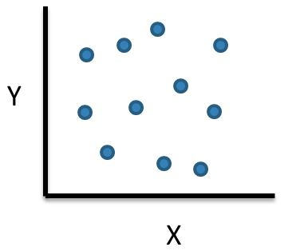
no correlation
positive correlation
negative correlation
5.
Identify the type of correlation that is present in the scatter plot.
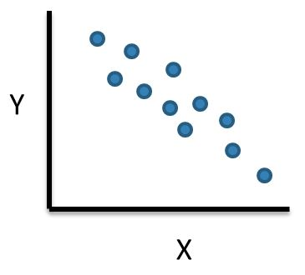
positive correlation
negative correlation
no correlation
An expression is shown below.
317x
What value of x makes the expression equal to
1817
317x=1817
x=1817/317=5.73185 or 6

36
15
3
6
4.
A seafood restaurant has $4200 to spend on crab and lobster. The restaurant needs to make a profit of at least $2000 on the order.
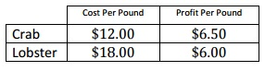
The possible combination of crab and lobster for this order are given by the inequalities:
12c+18l≤4200
6.5c+6l≥2000
where c represents the number of pounds of crab and l represents the number of pounds of lobster. The plot below represents the solution to this system of inequalities.
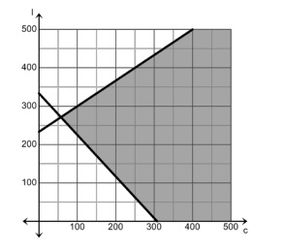
Which statement is NOT true about the possible combinations of crab and lobster for this order?
The restaurant can purchase 300 pounds of crab and 400 pounds of lobster.
The restaurant can purchase 400 pounds of crab and 500 pounds of lobster.
The restaurant can purchase 200 pounds of crab and 200 pounds of lobster.
The restaurant can purchase 50 pounds of crab and 300 pounds of lobster.
5.
An inequality is shown below.
|3x+9|≥36
Which values of x makes the expression true.
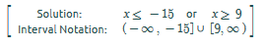
An expression is shown below.
317x
What value of x makes the expression equal to
1817
317x=1817
x=1817/317=5.73185 or 6
36
15
3
6
4.
A seafood restaurant has $4200 to spend on crab and lobster. The restaurant needs to make a profit of at least $2000 on the order.
The possible combination of crab and lobster for this order are given by the inequalities:
12c+18l≤4200
6.5c+6l≥2000
where c represents the number of pounds of crab and l represents the number of pounds of lobster. The plot below represents the solution to this system of inequalities.
Which statement is NOT true about the possible combinations of crab and lobster for this order?
The restaurant can purchase 300 pounds of crab and 400 pounds of lobster.
The restaurant can purchase 400 pounds of crab and 500 pounds of lobster.
The restaurant can purchase 200 pounds of crab and 200 pounds of lobster.
The restaurant can purchase 50 pounds of crab and 300 pounds of lobster.
5.
An inequality is shown below.
|3x+9|≥36
Which values of x makes the expression true.
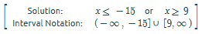

Which expression is equivalent to 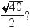
-Correct
21.
Seven baseball players are trying out for a team and the coach wants to see who can throw a baseball the farthest. The distance each player threw the baseball is recorded in the list below.

74 yards, 88 yards, 94 yards, 80 yards, 95 yards, 102 yards, 91 yards

Part 1:
Determine the median and mean for the 7 throws, to the nearest yard. Show or explain how you got your answers.
Mean=(74+88+94+80+95+102+91)/7=609/7=87
Median is middle value of data set , that is 91
The coach allowed two additional players to try out for the team, and each player threw the ball a distance of 91 yards.
Mean=(74+88+94+80+95+102+91+91+91)/7=806/9=89.56
Median is middle value of data set , that is 91

Part 2:
What effect will these two additional distances have on the median and mean distances you calculated? Show or explain your work to justify your answers.
Median is same for both, but mean is changed after adding two values.

22.
Which expression is equivalent to
-Correct
23.
Which set of numbers has the mean with the greatest value?
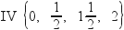
III
IV-Correct
I
II

